**IT332L – Prelim Activity 4**

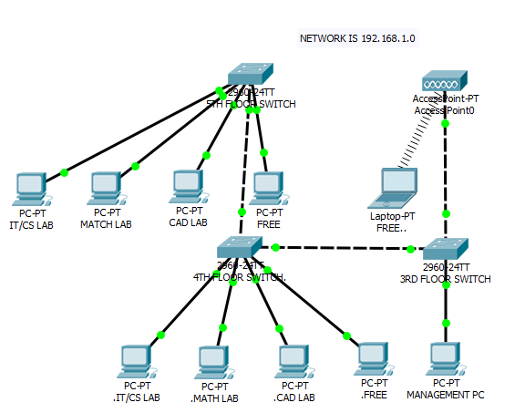

**Task:**

1. Create the topology above. Use 2960 switches and connect devices using the appropriate network medium. Add a wireless access point. Add a laptop and a smart device to connect in the wireless access point.

2. Assign IP addresses to the devices. Use 192.168.1.0 network.

3. Create the necessary VLAN for the different labs. Labs that are in the same VLAN can access each other.

4. Create a Management VLAN that Management PC can connect to access the configuration of the 4 switches. Management PC is the only end device that can access switch configurations.

5. Setup the wireless access point with an SSID and A WPA2-PSK pass phrase. SSID is ‘cisco’, pass phrase is ‘class’. Configure the wireless end devices and connect it to the wireless access point. The wireless access point should be in the same VLAN as the FREE lab.

6. Put passwords in all the intermediary devices. User privilege mode password is cisco. Global configuration mode password is class. Telnet password is cisco.

7. Test your connections.

Filename: LastnameFirstnameAct4.pkt